6. Natureofthetest

Section-1 MentalAbilityTest(MAT)

Thisisnon–verbaltest.Questionsarebasedonfiguresanddiagramsonly.Questionsaremeanttoassessgeneralmentalfunctioningofthecandidates.Thesectionisdividedintotenparashaving5questionseach.Givenbelowaresomeexamples:

PART-I(ODD-MANOUT)
Directions:
Inquestions1to5,fourfigures1,2,3and4havebeengivenineachquestion.Ofthesefourfigures,threefiguresaresimilarinsomewayandonefigureisdifferent.Selectthefigurewhichisdifferent.
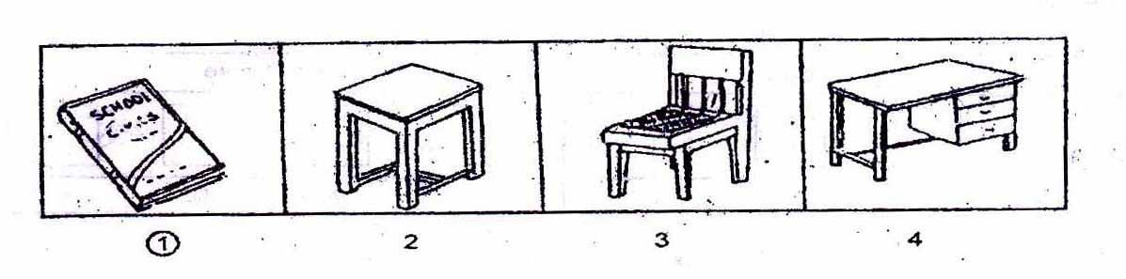
1
1
PART-II(FIGURE MATCHING)
Directions:
Inquestions6to10,aproblemfigureisgivenontheleftsideandfouranswerfiguresmarked 1,2,3,4aregivenontherightside.Selecttheanswerfigure whichisexactlythesameastheproblemfigure.
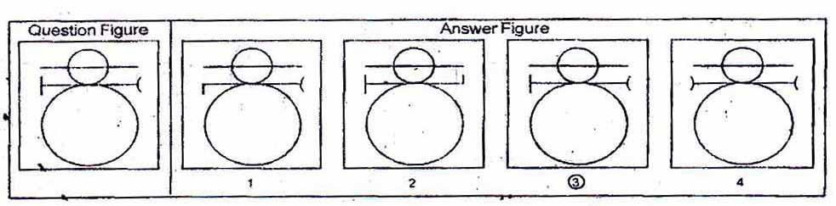
3
3
PART-III(PATTERN COMPLETION)
Directions:
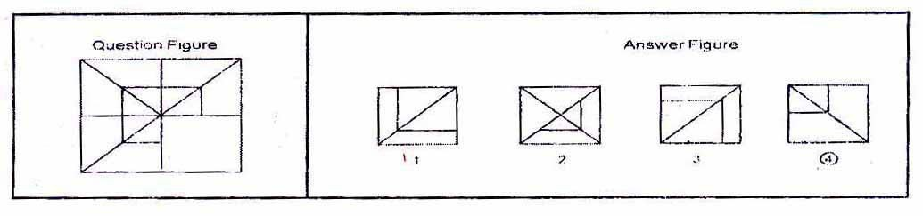Inquestions11to15thereisaproblemfigureonthelefthandside,apartofwhichismissing.Observetheanswerfigures1,2,3,4ontherighthandsideandfindouttheanswerfigurewhichwithoutchangingthedirection,fitsinthemissingpartoftheproblemfigureinordertocompletethepatternintheproblemfigure.
4
4

PART-IV(FIGURE SERIESCOMPLETION)
Directions:
Inquestions16to20,therearethreeproblemfiguresonthelefthandsideandthespaceforthefourthfigureisleftblank.Theproblem figuresareinaseries.Findoutonefigure
fromamongtheanswerfiguresgivenontherighthandside,whichoccupiestheblankspaceforthefourthfigureonthelefthandsideandcompletestheseries.
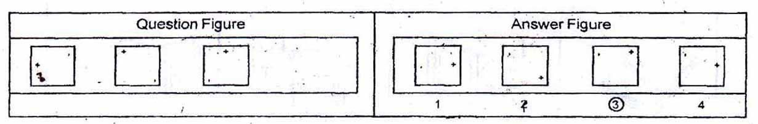
3

PART -V(ANALOGY)
3
Directions:

Inquestions21to25,therearetwosetsoftwoproblemfigureseach.Thesecondsethasamarkofinterrogation(?).Thereexistsarelationshipbetweenthefirsttwoproblemfigures.Similarrelationshipshouldexistbetweenthethirdandfourthproblemfigure.Selectoneoftheanswerfigurewhichreplacesthemarkofinterrogation.
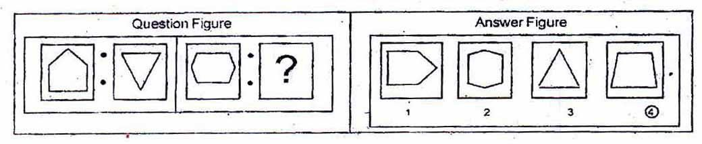
4
4
PART -VI{GeometricalFigureCompletion(Triangle, Square,Circle)}Directions:
Inquestions26to30onepartofasquareisonthelefthandsideasquestionfigureand
theotheroneisamongthefouranswerfigures1,2,3,4givenontherighthandside.Findoutthefigurethatcompletesthesquare.
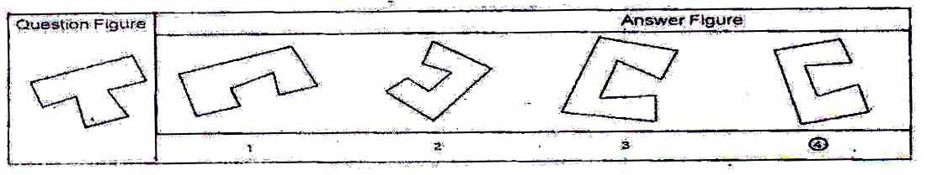
4

4
PART – VII(MIRRORIMAGING)
Directions:
Inquestions31to35thereisaproblemfigureontheleftsideandfouranswerfiguresmarked 1,2,3,4aregivenontherightside.Selecttheanswerfigure whichisexactlythemirrorimageoftheproblemfigurewhenthemirrorisheldatXY.
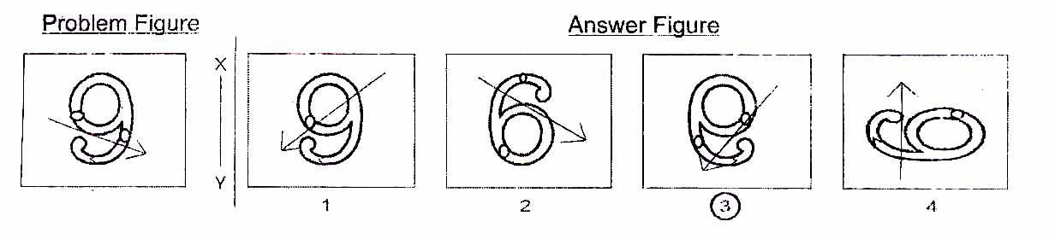
3
3
PART -VIII(PUNCHED HOLD PATTERN-Folding/Unfolding)Directions:
Inquestion36to40apieceofpaperisfoldedandpunchedasshowninproblemfiguresontheleftsideandfouranswerfiguresmarked1,2,3,4aregivenonrightside.Selecttheanswerfigurewhichindicateshowthepaperwillappearwhenopened(unfolded).

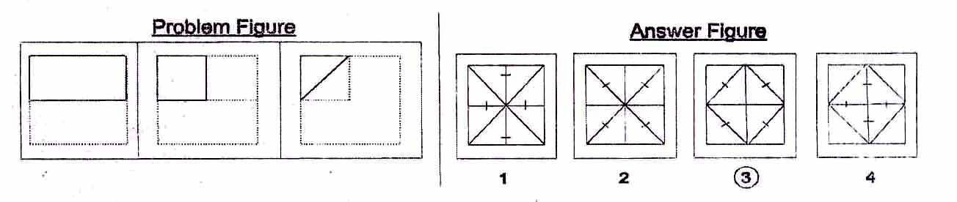
3
3
PART -IX(SPACE VISUALISATION)
Directions:
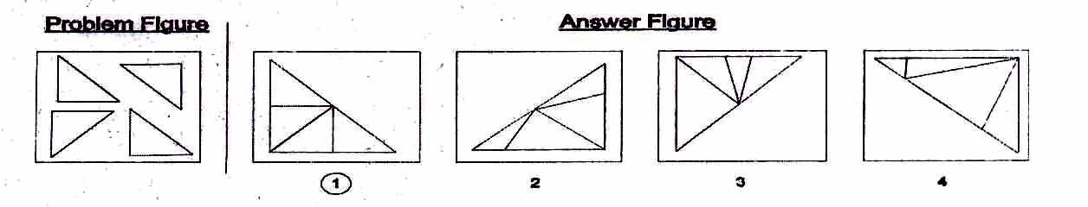Inquestions41to45aproblemfigureisgivenontheleftsideandfouranswerfigures,marked1,2,3,4aregivenontherightside.Selecttheanswerfigurewhichcanbeformedfromthecut-offpiecesgivenintheproblemfigure.
1
1

PART –X(EMBEDDEDFIGURE)

Directions:
Inquestions46to50aproblemfigureisgivenontheleftsideandfouranswerfigures,marked1,2,3,4aregivenontherightside.Selecttheanswerfigureinwhichtheproblemfigureishidden/embedded.

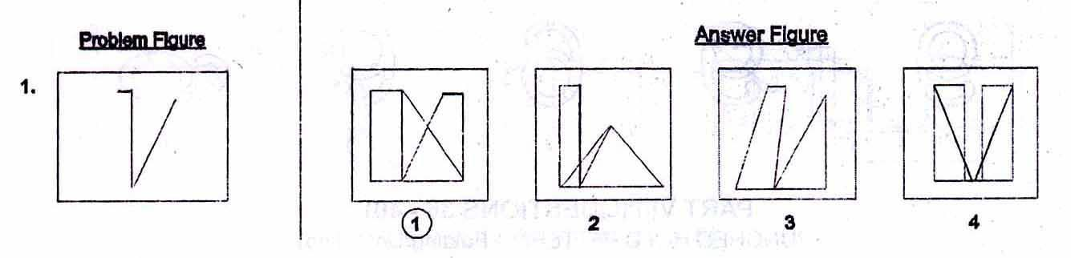
1
1
Section2:ArithmeticTest
Themainpurposeofthistestistomeasurecandidate'sbasiccompetenciesinArithmetic.AlltheTwenty-fivequestionsofthistestwillbebasedonthefollowing15topics

- Numberandnumericsystem.
- Fourfundamentaloperationsonwholenumber.
- Fractionalnumberandfourfundamentaloperationsonthem.
- Factorsandmultipleincludingtheirproperties.
- LCMandHCFofnumbers.
- Decimalsandfundamentaloperationsonthem.
- Conversionoffractionstodecimalsandvice-versa.
- Applicationsofnumberinmeasurelength,mass,capacity,time,moneyetc

- Distance,timeandspeed.
- Approximationofexpressions.
- SimplificationofNumericalExpressions,
- Percentageanditsapplications.
- Profitandloss.
- Simpleinterest.
- Perimeter,areaandvolume.
Note:-EmphasiswillbemoreontestingofunderstandingandApplicationoftheconceptsandskillsinvolved. Inordertoprovide some guidancetothecandidatesonthetypesofquestionsthatareexpectedinArithmeticlest,someexamplesaregivenbelow-

Example-1(TestofUnderstanding):
Whatistheprimefactorizationof1000?
1. 10x10x10
2. 2x5x5x10
3. 2x2x 2x5x5
4. 2x2x2x 5x5x5
Afactorizationofanumberissaidtobeaprimefactorizationif(i)theproductofthefactors(takingafactorasmanytimesasitoccurs)isequaltothegivennumber,and(ii)eachfactorisaprimenumber.Hereonlyserialnumber4satisfiesboththerequirements.Assuch,serialnumber4isthecorrectanswer.

Example2(TestofUnderstanding):
Whatistheaverageoffirstfouroddnumbers?

1. | 2.5
2. | 4
3. | 5
4. | 16
Thefirstfouroddnumbersare1.3.5and7.Theiraverage(l+3+5+7)/4.Assuch,serialnumber2isthecorrectanswer.

Example3(TestofApplication):

A1km.longgoodstrainisrunningatspeedofIkm.per3minutes,thetimetakenbythistraintopassthrough2kms.Longtunnelis:
  - 1minute
  - 3minute
  - 6minute
  - 9minute

Thetunnelis2km.longandthetrainisIkm.inlength,thetrainwillhavetocoveratotaldistanceof3km.inordertopassthroughthetunnelrunningataspeedof1km,per3minutes,thetrainwilltake9minutestopassthroughibistunnelandthatisthecorrectanswer.Assuch,serialnumber4isthecorrectanswer.

Section3:LanguageTest.

Themainpurposeofthistestistoassessreadingcomprehensionofthecandidates.Thetestconsistsofthreepassages.Eachpassageisfollowedby5questions.Candidatesshallreadeachpassagecarefullyandanswerthequestionsthatfollow.Inaddition,therewillbe10questionstotestgrammarandwritingskillsofcandidates.

Givenbelowisaspecimenpassageandthequestionsthatfollowthepassage.

PASSAGE
Forestsareusefultousinmanyways.Theyprovideuswithtimbertobuildhousesandmakefurniture.Forestsalsoprovideuswithwoodforfuelandmakingpaper.Theyprovideshelterforbirds,wildanimalsandinsects.Forestsbringrainfall.Existenceofforestsisveryimportantforthepreservationoftheecosystem.Thefactthatwehavetocareforanecosystemisindisputablyestablished.Wiseuseoftheenvironmentanditsresourcesareessentialforman'scontinuedsurvival.
- Topreservetheecosystem,existenceof...............isessential.
  - forests
  - animals
  - humanbeings
  - resources
- Oppositeofpreservation'is...............
  - conservation
  - construction
  - shelter
  - destruction

- Whichoneofthefollowingisnotasynonymof'wise'?
  - Sensible
  - Intelligent
  - Humorous
  - Judicious

- Carpentersdependonforestsbecausetheyprovide...............
  - woodforfuel
  - woodformakingpaper
  - timbertomakefurniture
  - housesforanimals

- Wildanimalswillbecomehomelessif...............
  - papermillsaredestroyed
  - housesarebuilt
  - forestsaredestroyed
  - ecosystemistakencareof

